
Machine Classification and Yield Analysis for Purlin Manufacturing
A Machine Learning Lab Project Report
Production logs: April – October 2026
Riddhi Shelke | A9-40
Sanchi Sharma | A9-57
Anupama Sanjeevan | A9-44

1. Introduction
Purlin production runs on three machines (New Machine, Machine No.1 and Machine No.2). Each job is logged with its steel coil, customer, dimensions, coating weight and number of purlins produced. This project builds an end-to-end machine-learning pipeline on those logs: automated data cleaning, model training and evaluation, a machine recommender and an interactive application for inference.
Two tasks were defined. Task 1 predicts which machine ran a job from its specification. Task 2 explores regression of production yield. The main analysis (Sections 2–8) uses the first data snapshot, April to June 2026 (2,953 jobs). Section 9 then extends the data to October 2026 (9,005 jobs) to test whether the results hold on later months. They do not hold in full, because the plant’s routing of customers to machines changes over time, and Section 9 reports why.

2. Data and Preparation
The raw logs were converted to a clean dataset (purlin_clean_apr_jun.csv, 2,953 rows, 78 production days from 2 April to 28 June 2026). Numeric columns were coerced with errors set to NaN, dates parsed, and text fields stripped and upper-cased. The cleaning steps and row counts were:
Step | Rows remaining
Raw rows (3 machine sheets) | 2,975
1. Remove downtime (“MACHINE OFF”) and blank rows | 2,968
2. Drop rows missing thickness, width, length or purlin count | 2,963
3. Remove exact duplicate rows | 2,954
4. Remove implausible values (a 2,308 mm wide purlin) | 2,953
Table 1. Cleaning steps for the April–June snapshot.
Customers were consolidated into 18 groups (PARTY_GROUP), including a catch-all “OTHER” group. Missing GSM (about 10% of rows) was imputed with the median GSM of the same thickness and flagged.

2.1 Target distribution
The classes are imbalanced: New Machine 2,119 jobs (71.8%), Machine No.1 509 (17.2%), Machine No.2 325 (11.0%). The class mix also drifts over time: Machine No.1 ran 250 jobs in April but 109 in June, while New Machine rose from 619 to 991. Because of this imbalance, accuracy alone is misleading and macro-F1 is the primary metric.

2.2 Derived quantity
Unit weight is an exact function of the dimensions in this data: UNIT_WEIGHT_KG = thickness × width × length × 7850 / 10⁹ (steel density 7,850 kg/m³; ratio of 1.000 on every row). It therefore adds no independent information, although it is retained as a convenient scaled feature.

3. Methodology (Task 1)

3.1 Features
Six numeric features (thickness, width, GSM, length, purlin count, unit weight) were standardised; customer group was one-hot encoded with unknown categories ignored. All preprocessing lives inside a scikit-learn Pipeline so that scaling is fitted only on training folds.

3.2 Models and tuning
Five classifiers were trained: Logistic Regression, K-Nearest Neighbours, SVM with RBF kernel, Random Forest and Gradient Boosting. Each was tuned with five-fold stratified GridSearchCV optimising macro-F1 (class weighting “balanced” where supported). Every model was run with and without the customer feature to measure its contribution.

3.3 Two evaluation splits
- Random split: stratified 80/20 (2,362 train / 591 test).
- Time split: train on April–May (1,784 rows), test on June (1,169 rows). This mimics deployment, where the model predicts future jobs.
A majority-class predictor (always “New Machine”) is the baseline: macro-F1 0.278 on the random test set and 0.306 on the time-split test set; accuracy 0.717 and 0.848 respectively.

4. Results

4.1 Model comparison
Model (with customer) | Random acc. | Random F1 | Time acc. | Time F1
Gradient Boosting | 0.978 | 0.964 | 0.869 | 0.706
Random Forest | 0.975 | 0.957 | 0.846 | 0.728
KNN | 0.946 | 0.915 | 0.923 | 0.759
SVM (RBF) | 0.931 | 0.889 | 0.958 | 0.861
Logistic Regression | 0.880 | 0.824 | 0.749 | 0.617
Majority baseline | 0.717 | 0.278 | 0.848 | 0.306
Table 2. Test-set accuracy and macro-F1 for each model and split (April–June data).
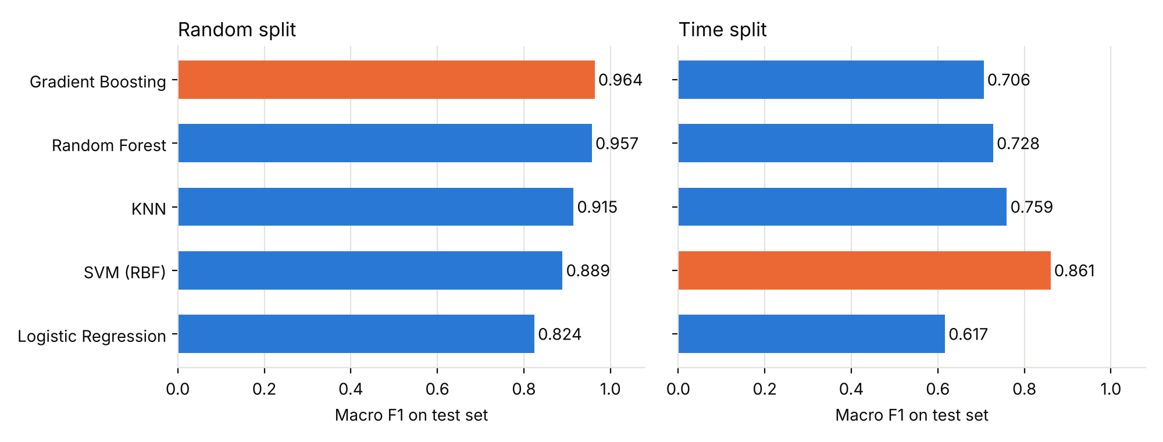
Figure 1. Macro-F1 on the test set; the best model in each split is highlighted.
Accuracy is above 85% for almost every model on both splits. On the random split the tree ensembles dominate (Gradient Boosting 0.964 macro-F1, Random Forest 0.957). On the time split the ranking changes: SVM leads at 0.861 macro-F1 (95.8% accuracy) and both tree ensembles drop to roughly 0.71–0.73. Cross-validation scores (0.95 for the ensembles) were far above the time-split test scores, a sign of distribution shift.

4.2 Error analysis
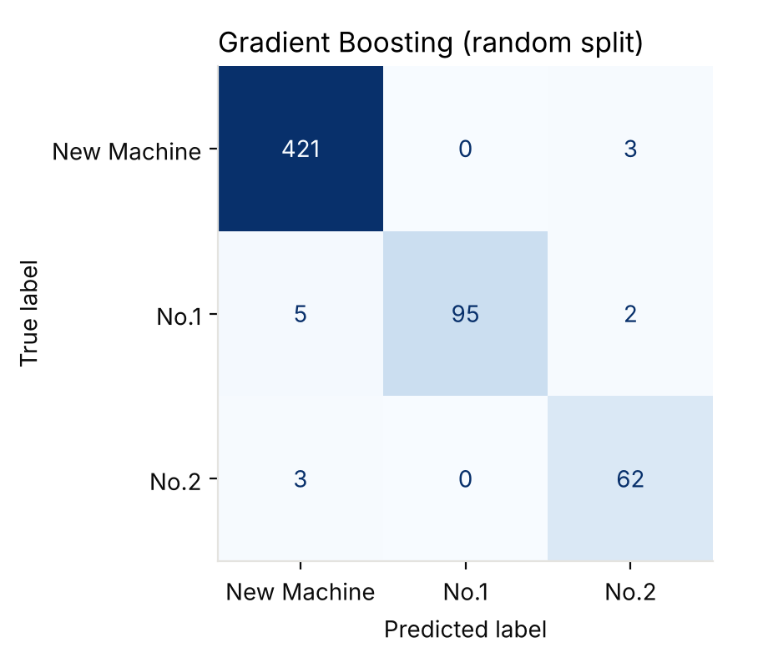
Figure 2. Gradient Boosting confusion matrix on the random-split test set.
Of 591 test jobs, 578 were classified correctly (97.8%). There were 13 errors in total; Machine No.1 had the most misses (7 of 102), mostly predicted as New Machine. No class was systematically ignored, which the balanced class weights help to ensure.

4.3 Feature importance and the customer feature
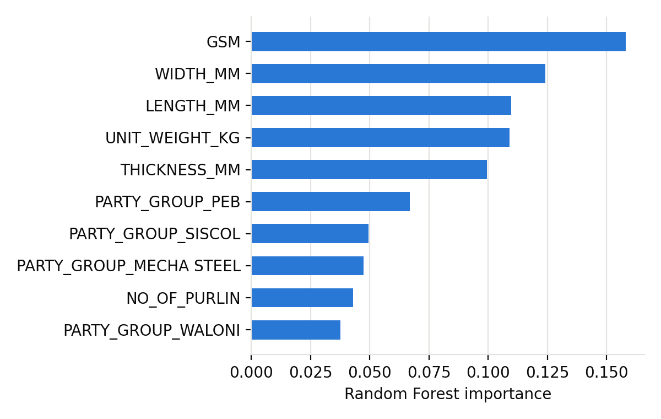
Figure 3. Top ten Random Forest feature importances (random split).
Coating weight (GSM) and the geometry features carry most of the signal, followed by several customer groups (PEB, SISCOL, MECHA STEEL). Removing the customer feature confirms its importance:
Model | Random F1 with | Random F1 without | Time F1 with | Time F1 without
Gradient Boosting | 0.964 | 0.880 | 0.706 | 0.542
Random Forest | 0.957 | 0.851 | 0.728 | 0.634
SVM (RBF) | 0.889 | 0.715 | 0.861 | 0.537
KNN | 0.915 | 0.806 | 0.759 | 0.578
Logistic Regression | 0.824 | 0.630 | 0.617 | 0.587
Table 3. Effect of removing the customer-group feature (macro-F1).
Specifications alone are therefore not enough to separate the machines; customers are routed to particular machines, and that routing is what the models exploit.

5. Discussion

5.1 The random split overstates performance
The same job (same customer and dimensions) is typically produced from several coils, so near-identical rows appear many times. In this dataset 43.8% of the random-split test rows have an exact feature match in the training set, against 0.2% for the time split. A random split therefore partly tests memorisation. The time split is the more honest estimate of how the model will behave on new jobs.

5.2 Model choice
The 0.964 vs 0.861 gap is large enough to change the recommendation. Gradient Boosting wins on the random split, but SVM is the most robust under temporal shift (accuracy 0.958, macro-F1 0.861). Only SVM clearly beats the 0.848 majority-class accuracy on the time split; the tree ensembles reach 0.846–0.869, barely above guessing “New Machine” by accuracy alone, although their macro-F1 is far above the baseline’s 0.306.

5.3 Limitations of the April–June snapshot
- Only three months of data; the June test set has a different class mix from the training months.
- Machine assignment may depend on factors not recorded (operator decisions, machine availability, scheduling).
- Best-model selection and exact scores can vary slightly between scikit-learn versions and seeds.

6. Task 2: Yield Regression
Yield is production weight as a percentage of the logged coil weight (YIELD_PCT = PRODUCTION_KG / QTY_WT × 100) and is available for only 534 of the 2,953 rows (those with a recorded coil weight). Two identities were verified to floating-point precision: production equals unit weight × purlin count, and yield equals production divided by coil weight. Three feature sets were compared with Ridge, Random Forest and Gradient Boosting, using 5-fold cross-validation and a time split (train April–May, 363 rows; test June, 171 rows). The mean predictor scores R² = −0.03 on the time split.
Feature set (Gradient Boosting) | CV R² | CV MAE (pts) | Time R² | Time MAE (pts)
A: job specs only | 0.33 | 26.3 | 0.02 | 32.4
B: + purlin count | 0.68 | 15.9 | 0.61 | 18.8
C: + purlin count + coil weight | 0.93 | 7.0 | 0.90 | 8.2
Table 4. Yield regression (full results in results_yield_apr_jun.csv).
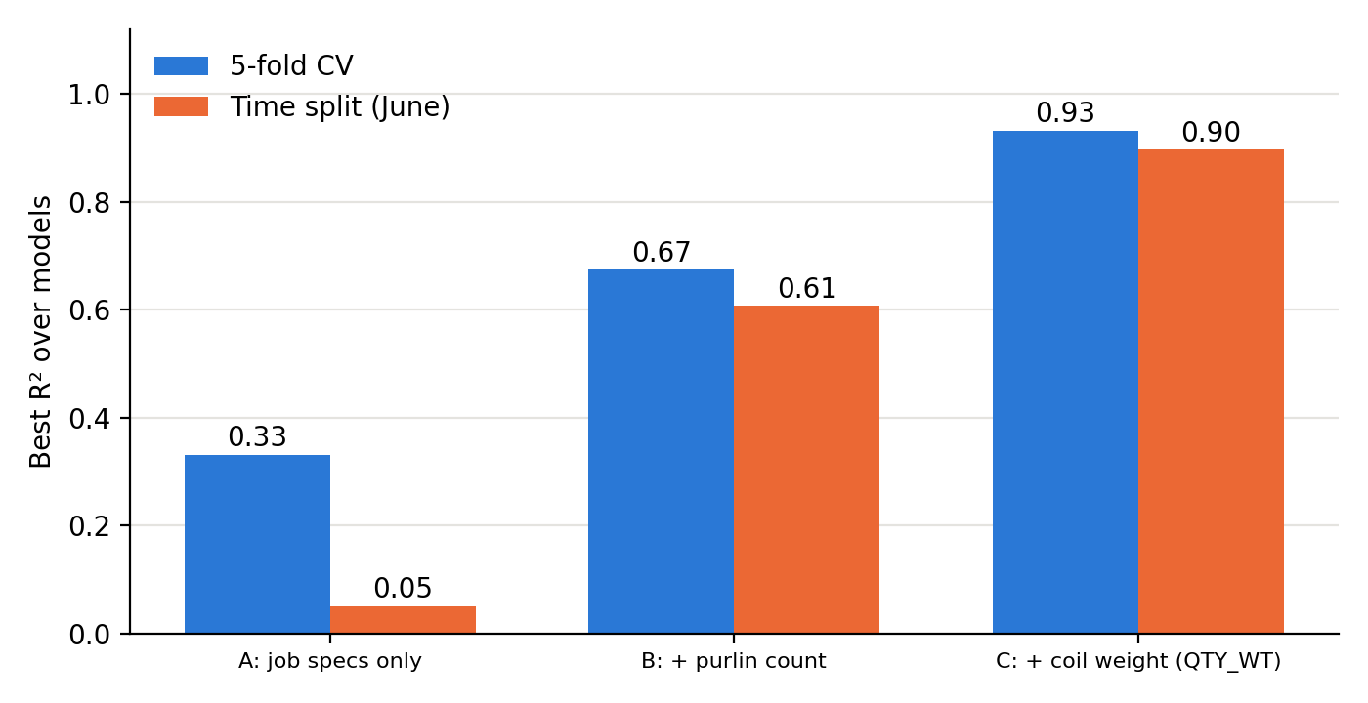
Figure 4. Best R² per feature set under cross-validation and the June time split.
From job specifications alone, yield is essentially unpredictable out of sample (time-split R² of 0.02–0.05). Adding the purlin count helps (about 0.61 on the time split), and adding the coil weight lifts R² to about 0.93. The last jump is arithmetic, not learning: with purlin count, unit weight and coil weight known, yield follows from a closed-form formula that scores R² = 1.000 on this data, and neither the purlin count nor the final coil allocation is known before a job is planned. The pre-production result is set A: yield cannot be forecast from specifications.

7. Machine Recommender
The classifier predicts which machine the plant has used; it cannot say which is best. Almost no job configuration ran on more than one machine (11 of 1,216), there is no cost, speed or downtime data, and yield is confounded by the job mix on each machine, so a “best machine” model cannot be supported by this data. Instead, src/recommend.py combines the model’s probabilities with each machine’s observed range of thickness, width, GSM and length. A job outside a machine’s observed range is flagged as “not previously run in this range”. These are empirical ranges, not engineering limits, and should be confirmed with the plant. For example, Machine No.1 only ran widths of 346–365 mm.
Ranges learned from April–May were tested on the 1,169 June jobs, asking whether the machine that actually ran each job was inside its range:
Range margin | Actual machine in range | Jobs with no machine in range | Avg. machines in range
None (strict min/max) | 92.8% | 81 | 1.94
5% of each span | 97.6% | 28 | 2.01
10% of each span | 99.9% | 1 | 2.09
Table 5. Out-of-sample validity of the observed ranges (train Apr–May, test Jun).
Strict ranges wrongly excluded the real machine for 7.2% of June jobs, mostly New Machine jobs at widths beyond the April–May range (47 jobs) and Machine No.1 jobs at thickness 1.40 mm against an observed minimum of 1.42 mm (32 jobs). A 10% margin removes nearly all such cases. The margin was chosen after seeing June, so 99.9% is slightly optimistic, and out-of-range machines are shown as warnings, not hard exclusions.
June test, time split | Acc. (model) | F1 (model) | Acc. (+ranges) | F1 (+ranges)
SVM | 0.946 | 0.835 | 0.946 | 0.835
Random Forest | 0.808 | 0.705 | 0.944 | 0.834
Table 6. Recommendation quality with and without the range check (models refitted on April–May).
The range check leaves the SVM unchanged but lifts Random Forest from macro-F1 0.705 to 0.834, so the recommender depends much less on the choice of classifier. These SVM figures differ slightly from Table 2 because the probability-enabled SVM used here has no grid search.

8. Deployment: Streamlit Application
The app (app/streamlit_app.py) loads a saved model and lets a user enter thickness, width, length, GSM, purlin count and customer group; unit weight is computed automatically. It shows the recommended machine and, for all three machines, whether the job is inside that machine’s observed range, with the reason when it is not. It warns when inputs fall outside the training range or the customer is unknown, rebuilds the model automatically if the saved file is missing or incompatible, and uses a single-column responsive layout that works on mobile browsers. The deployed model is a Gradient Boosting classifier fitted on all data through October (Section 9). [Add live URL and desktop / phone screenshots here.]

9. Extension: Do the Results Hold on Later Months?
After the first analysis, the production workbook was extended to 26 October 2026. The same pipeline was rerun on the larger dataset to test whether the April–June findings generalise.

9.1 Extended data
The raw workbook now holds 9,083 rows. Mixed date formats and corrupted dates were repaired, and more implausible values (width 40 mm, length 88,556 mm, 0 or 643 purlins) were removed, leaving 9,005 jobs after the same four steps (9,083 → 9,076 → 9,055 → 9,017 → 9,005). New Machine accounts for 5,596 jobs (62.1%), No.1 for 2,050 (22.8%) and No.2 for 1,359 (15.1%). The new customers (for example SHREE SHAKTI, PM and PRAGYA TRADE HUB) and spelling variants were consolidated into 31 named groups plus “OTHER”. The time split now trains on April–August (6,117 jobs) and tests on September–October (2,888 jobs); the random split is 7,204 / 1,801. Baselines: accuracy 0.621 and macro-F1 0.255 (random), 0.507 and 0.224 (time). Gradient Boosting was replaced by scikit-learn’s histogram implementation (a LightGBM-style algorithm), which is far faster on this larger data.

9.2 Results on the extended data
Model (with customer) | Random acc. | Random F1 | Time acc. | Time F1
Gradient Boosting | 0.939 | 0.921 | 0.534 | 0.415
Random Forest | 0.939 | 0.918 | 0.535 | 0.400
KNN | 0.889 | 0.852 | 0.492 | 0.370
SVM (RBF) | 0.846 | 0.811 | 0.531 | 0.450
Logistic Regression | 0.772 | 0.721 | 0.478 | 0.391
Majority baseline | 0.621 | 0.255 | 0.507 | 0.224
Table 7. Extended data (April–October): test-set accuracy and macro-F1.
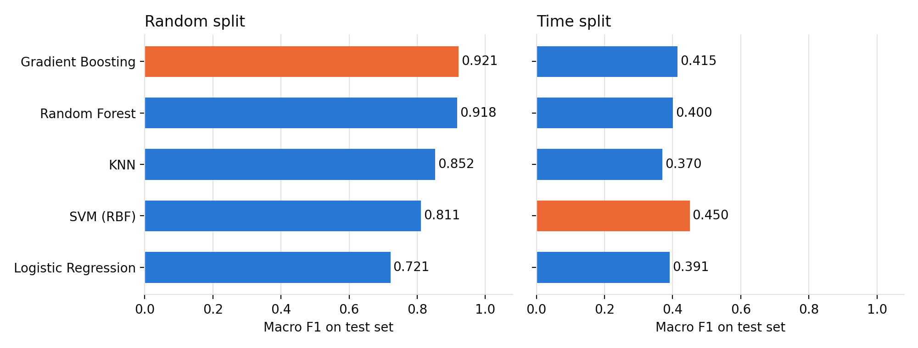
Figure 5. Macro-F1 on the extended data; the best model in each split is highlighted.
On the random split the models still exceed 85% accuracy (93.9% for Gradient Boosting and Random Forest, 88.9% for KNN). On the time split, however, no model is meaningfully better than the 50.7% majority baseline in accuracy (best 53.5%), although macro-F1 (0.37–0.45) is well above the baseline’s 0.224. The April–June time-split numbers (Table 2) therefore did not carry over to later months.

9.3 Why: routing drift
Two things explain the gap. First, the random split is again optimistic: 39.4% of its test rows have an exact feature match in the training set, against 4.9% for the time split. Second, and more important, the plant’s routing changed. SISCOL ran only on New Machine from April to August (1,638 of 1,638 jobs), but in September–October 148 of its 278 jobs went to Machine No.1. New customers also appeared late: SHREE SHAKTI (269 of 409 jobs on No.2) and PM (180 of 195 on No.2) are almost absent from the training months, and 10.6% of the test jobs belong to customer groups never seen in training. New Machine’s share of jobs ranged from 85% in June to 47% in September. A model trained on April–August cannot know about these changes, and the June test month in the first analysis was an unusually easy one (85% New Machine, so the majority baseline already scored 84.8%).

9.4 Using recent routing
A legitimate improvement is to give the model each customer’s recent routing, computed only from jobs on strictly earlier dates. With a 14-day lookback, a Random Forest trained on April–August reaches 71.8% accuracy (macro-F1 0.689) on September–October, up from 53.5% (src/experiment_recent_routing.py). Retraining monthly with these features gives 73.0% for August, 78.4% for September and 59.9% for October.
A weekly walk-forward test (src/experiment_walkforward.py) retrains every week on all earlier jobs and also adds the machine that last ran the same job. Over the 2,888 jobs of 1 September – 26 October the retrained Random Forest reaches 70.2% accuracy (macro-F1 0.696), while the simple rule “use the machine that ran the same job last time” reaches 76.0% (macro-F1 0.759). The rule is right for 84.9% of the 31.1% of jobs that have an earlier job with identical customer, dimensions and length, and for 72.0% of the rest. Forward-looking accuracy above 85% is therefore reachable for jobs that repeat an earlier job, but not for new jobs overall; reaching it for all jobs would need information not currently logged, such as machine availability or the planned schedule.

9.5 Yield on the extended data
Yield is available for 1,406 rows. The pattern is unchanged (Gradient Boosting or Random Forest, best per set): job specifications alone give CV R² 0.31 and time-split R² 0.06; adding the purlin count gives 0.75 and 0.62; adding the coil weight gives 0.96 and 0.94. As before, the last result reflects the exact formula (R² = 1.000), not forecasting skill.
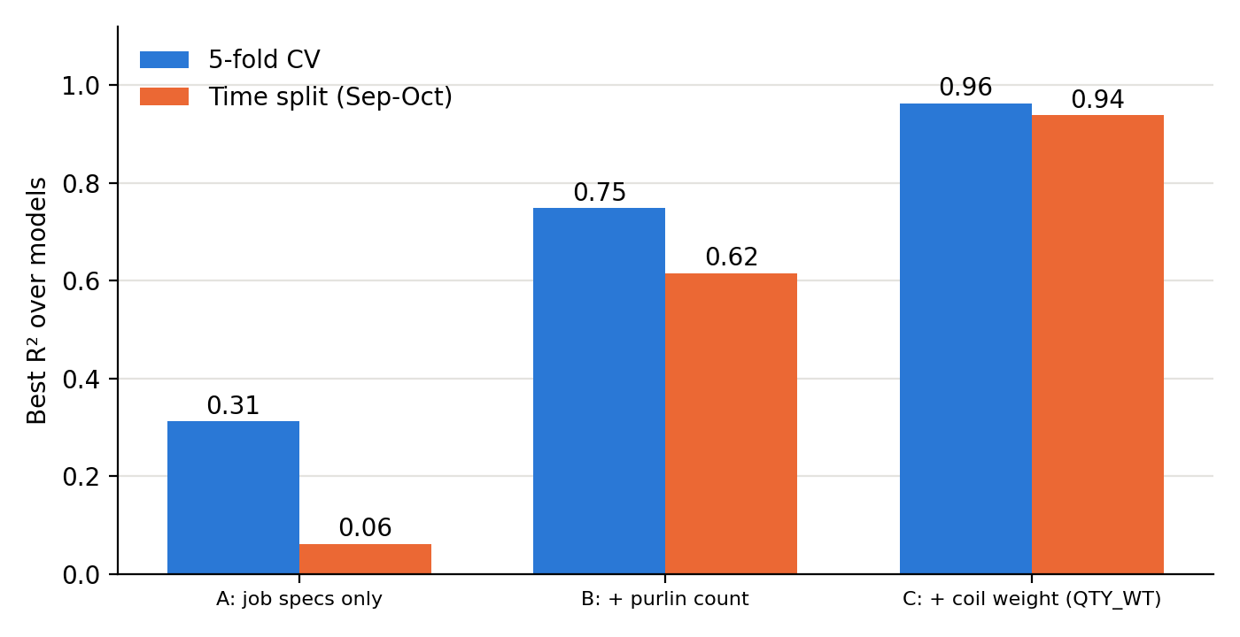
Figure 6. Yield regression on the extended data (n = 1,406): same pattern as Figure 4.

10. Conclusions
- Machine type can be predicted well from job specification plus customer group on the April–June data: accuracy 85%–98% for most models on both splits, and macro-F1 up to 0.96 on a random split and 0.86 on a June time test, versus baselines of 0.28–0.31.
- Customer group is the key signal; without it macro-F1 falls by 0.03–0.32 depending on model and split.
- Random-split results are inflated by repeated jobs; time-based validation should be used.
- Extending the data to October shows that these results do not carry over to later months: accuracy on September–October is about 53% for static models, because customers are routed to different machines over time. Recent-routing features and regular retraining raise it to roughly 70–78%, and the rule “repeat the last machine for the same job” reaches 84.9% on jobs that repeat.
- Yield cannot be predicted from specifications; the R² of 0.93–0.96 with purlin count and coil weight is an exact formula.
- The data supports a recommender (observed ranges plus historical routing), not a proven best-machine model.
Limitations: seven months of data; machine choice depends on scheduling and availability that are not recorded; plausibility limits and customer groupings are documented choices that should be confirmed with the plant. Future work: log per-job outcomes (run time, downtime, scrap, cost) and the planned machine, retrain on a schedule, and define a planned-versus-actual yield measure per coil.

Appendix: Repository
See README.md. src/ holds prepare_data.py, train_machine.py, train_yield.py, train_final.py, recommend.py and the two experiments; src/legacy/ holds the scripts that produced the April–June results (Sections 2–8), with their data (data/processed/purlin_clean_apr_jun.csv), results (results_machine_apr_jun.csv, results_yield_apr_jun.csv) and figures (figures/apr_jun/). The extended-data results are in results_machine.csv, results_yield.csv and figures/.

